Growth Hacking:

Definitions:

Key Performance Indicator (KPI): a number that helps you get a quick grasp of how things are going within your company. (How many new subscriptions, how many cancelled today) By simply looking you get a sense of company trends.

Viral Coefficient (K): a number that tells you how many new people are brought into your product because of your existing users. (Example: if every 50 visitors to your product bring in 100 new visitors to your product then your K would be 2.) Anything above 1 means that you are growing virally.

Cohorts: A portion of your users based on when they signed up for your product. Use cohorts to keep data clear. If every month your KPIs are improving for new cohort’s month over month then things are going in the right direction.

Segments: Like cohorts, but instead of basing the group on signup date, you base the group on other segmenting’s factors. (Male, female, to see how they behave differently)

Multivariate Testing (A/B Testing): when you make product change that are only seen by some of your users. Then you can see f version A or B gives you the results you want. Bandit testing is a continuous form of A/B testing that always send people toward the best performing options, so the experiment never ends.

Customer Acquisition Cost (CAC): Amount of money it takes to get a new customer. Important to know and can be found in customer profile document in dropbox.

Lifetime Value of Customer (LTV): the expected amount of money you’ll make on someone throughout their entire lifecycle on your product. Segments come in handy when calculating LTV because you might discover that certain segments of your users have a much higher LTV than other users.

Part 1: What is Growth Hacking?

* Marketers are important, but early in a startup you need someone with a narrower focus on growth.
* The nature of internet products has produced a new way to think about growth. Product features can now be directly responsible for growth.
* Distribution channels are being redrawn, and those that understand the movement of people online will have control over where they end up.
* Growth hackers, using their knowledge of product and distribution, find ingenious, technology-based, avenues for growth that sometimes push the bound of what is expected or advised.
* AirBNB is a notable example of growth hacking.
* Growth hacking shows us a trend that will infiltrate more than the marketing department. Growth matter and multiple roles within companies will someday reflect that.
* Growth hacking is primarily found in startups but it will eventually be found in larger organizations.

Part 2: The Profile of a Growth Hacker

* You don’t have to be a programmer to be a growth hacker
* Traditional marketers can become growth hackers if they narrow their focus and depend their skill set.
* Most growth hackers are not unethical
* Growth hackers rely heavily on analytics.
* Growth hackers are proficient at several disciplines, but must excel at some of them to do their work effectively. (T shape, V shape, U shape)
* Despite their reliance on analytics, growth hackers are also right brained, as they use creativity, curiosity, and qualitative research at times. (Curiosity killed the cat but a lack of curiosity with kill your product.)
* 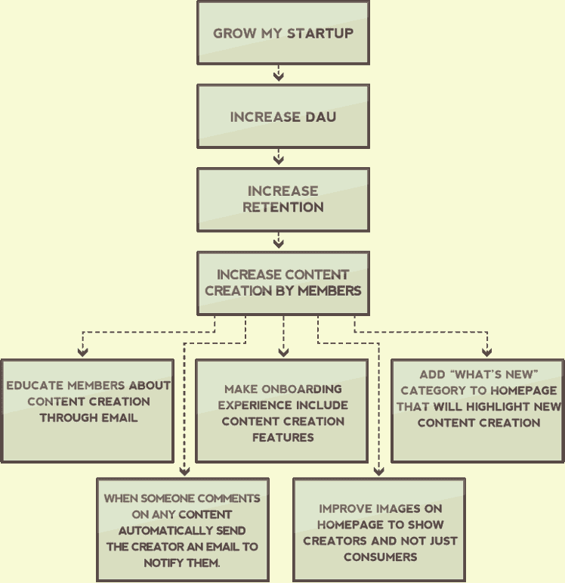Growth hackers are obsessive about growth. This allows them to persist until they uncover the tactics that will work, and it allows the m to build upon minor successes as they slowly move their product forward.

Part 3: The Process

* Define actionable goals
* Implement analytics to track your goals.
* Leverage your existing strengths
* Execute the experiment
* Optimize the experiment
* Repeat

Part 4: The Growth Hacker Funnel

* Funnels help guide things which are hard to control like liquid or people.
* The growth hackers funnel has 3 phases:
  + Get Visitors-finding ways for people to land on your product.
  + Activate Members- helping people take predefined actions in your product.
  + Retain Users- helping people become habitual users of your product.
* It’s hard to know what good conversion rates are for your product, but following things help:
  + Always be improving relative to yourself.
  + Find companies online who have published their conversion rates.
  + Find allies that will let you see their numbers
  + Conversion rates affect each other within the funnel, so view the funnel as a whole.
* You should place your energy into places where you have weak conversion ratios.
* You need to grow some to find product-market fit, but you shouldn’t focus on growth exclusively until you find product-market fit.
* This funnel is a simplified version of Dave McClure’s framework.

Part 5: Pull Tactics for Getting Visitors

* Don’t just focus on traffics, it’s important but it’s not everything.
* There are 3 ways to get traffic to your site
  + Pull-You entice them to come to you.
  + Push- You coerce them to come to you
  + Product- You use your product itself to bring them to you.
* These are 12 pull tactics that we can use.
  + Blogging or Guest Blogging (Bring others to blog for us/we blog for them)
  + Podcasting or Guest Podcasting.
  + Ebooks, Guides, and Whitepapers
  + Infographics (Info graphic on time saving calculator)
  + Webinars (Webinar that convert into Demo)
  + Conference Presentations
  + SEO
  + Social Media
  + Contests
  + Marketplaces
  + Deal Sites
  + Leverage Other People Audiences

Part 6: Push Tactics for Getting Visitors

* A push tactic usually involves interrupting the content that is being consumed.
* Normally cost money
* Since money is involved with push tactics you must understand the lifetime value of your customers, so that you don’t spend more money on a customer then you’ll make from them. (Found in Customer profile document)
* Four push tactics we can use
  + Purchase Ads (Social Media, websites)
  + Promo Swap (Swap tweets, swap Facebook posts, sponsored email swap, giveaway swap)
  + Affiliates
  + Direct Sales

Part 7: Product Tactics for Getting Visitors

* Most products don’t go viral (However the ability to use our product to get new visitors is one of the most exciting aspects of growth hacking.)
* Product tactics have an amplifying effect on other tactics.
* Here are 6 product tactics we can use
  + Network Invitations (use existing networks to our advantage)
    - Phone contacts
    - Email contacts (make it easy to invite friends)
    - Social contacts
  + Social Sharing
  + API Integrations
  + Backlinks (Hotmail example included a link at the bottom of each email that was sent saying “Get your free email at Hotmail”, and a viral loop was born)
  + Incentives (Get extra add ons for sharing on facebook, or liking our page, follow us on twitter, getting 3 referrals for a free month)
  + Organic (Word of mouth)
    - Simple spreads
    - Pain Relieving spread
    - Fun products spread
    - Unique product spread
    - Surprising products spread
* Getting traffic is a recipe, not a single ingredient
* The recipe is ALWAYS changing
* Don’t just copy the other recipes of other startups

Part 8: How to Activate Members

* Getting visitors to your product is not enough. You need to activate them.
* Activation is when someone takes an action that you decided was necessary for the success of your product. (email address, create an account, read something, share something, fill out something, interact with someone.)
* You should only have one activation goal for any given section of your product.
* Activation goals will vary based on your product.
* Here are 6 different activation tactics
  + Landing Pages (Get them to what they are looking for right away, if they come from social media get them to the page that we have our social media stuff on, if they come to sign up, get them to the sign-up page)
  + Copywriting (Headline should mention our unique value prop, short is good for less expensive, long is good for expensive)
  + Calls to Action
  + Onboarding (Helpful tips that pop up on website, intercom)
  + Gamification (Progress bars to their first full use of ScoutSheet, awards to be tweeted or shared on facebook, leaderboards within their company)
  + Pricing Strategies

Part 9: How to Retain Users

* Retention is the most important of our funnel.
* 8 Tactics to retain users
  + Staged Traffic
  + Speed to Aha (Show we are going to save them X, provide them Y, and make Z much more valuable as quick as possible)
  + Don’t Fear Email
  + Alerts and Notifications (Only Relevant Updates)
  + Exit Interviews (Ask why the cancelled, contact them personally)
  + The Red Carpet (Roll out red carpet for most engaged users, send shirts, email shout outs, retweet them often, access to early content)
  + Increase Value (Add Features, and Subtract Features)
  + Community Building (Customer Support, Documentation, have them interact with each other with social features)
  + Make Them Happy (All comes down to happiness)